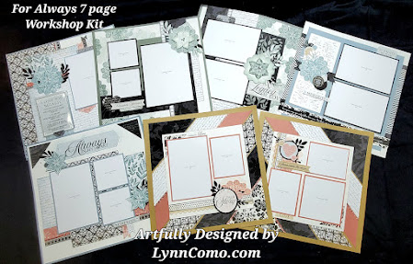
FOR ALWAYS by Lynn Como Scrapbooking Kit Shopping List
When it comes to designing artwork, I think you’ll fall in love with my For Always designs to create 7 scrapbook pages. I incorporated quite a few techniques on these pages:
- Cutting and placement of the diagonal layout (video on ‘how to’ included with your purchase)
- Adding texture with Sprigs & Leaves:
  - Embossing folder/sanding
  - Thin Cut and all “BITS” are used
  - Stenciling/Blending Brush
- Plus Stamping/Piecing the Lace Doily in 1st, 2nd and 3rd generation ink.
Yes, the videos will be included for you to watch and learn HOW! I love this feature! Here’s what you need to purchase to receive my Cutting Guides, Videos and Artwork tips:
CC62312 For Always Scrapbook Kit $33.95
  - If you have purchased CC32322 through another consultant, you are required to make a $50 minimum purchase of any product on my website HERE.
  - If you are a valued VIP/Customer of mine, and purchased this workshop on my website already, please check your stash and order the additional supplies needed.
Additional Items I used to create My Artwork:
- NEW B1418 Love Doily Stamp Set $11.95
- C1980 Ornamental Borders stamp set $15.95
- NEW Z4753 Sprigs and Leaves BUNDLE (contains all items below) $58.80
  - D2166 Sprigs & Leaves stamp set $19.95
  - Z4752 Sprigs & Leaves Stencils $6.95
  - Z4750 Sprigs & Leaves Slimline thin cut $19.95
  - Z4751 Sprigs & leaves Embossing Folder $9.95
- INKS needed @ $10.95 each: Toffee, Desert Rose, Rosemary, Mist, Black
- Z3743 Circle thin Cuts $14.95
- Z3842 Desert Rose Glitter Paper $8.95
  - If you like shimmer trim and want to cut it, we still have Z5017 Desert Rose Shimmer Trim for $6.50
- Z4224 Black Shimmer Brush $5.95
- Z4572 Blending Brush $15.95 and/or sponge daubers
Basic Tools needed:
- Z3396 Cut Rail Paper trimmer $59.95 (or your own brand)
- Z1279 Versamat $19.95 (we use this to cut the diagonals strips)
- Z4643 T-Square Ruler $25.95 (perfect to line up for straight lines and as a ruler)
- Z1836 Non-Stick Micro Tip Scissors $19.95 (cuts through glue, no stick!)
- Adhesives; Glue Dots (mini and larger); Foam Tape

Shop: LynnComo.CTMH.com
Blog: LynnComo.com
Email: ilov2cr84u@gmail.com

